

BRIEFING NOTE

**Trauma and Emergency   
General Surgery**

There are two areas where changes have been made to services at West Cumberland Hospital that were not explicitly covered by previous public consultation and where some formal consideration is therefore necessary:

* Trauma – where a decision was made on safety grounds, in 2014, to stop minor trauma operations, emergency admissions and on call services.
* General surgery – where there has been a gradual shift in lower-risk emergency surgery to Carlisle.

The underlying aim in relation to changes made to both of these services are identical… the overriding primary objective is to safeguard patients.

Well-evidenced and nationally acknowledged improvements to patient outcomes have been achieved as a result of the changes with a sustained reduction in deaths and improvements in quality indicators.

In addition the changes allowed us to reduce our use of locum doctors which has saved the NHS nearly half a million pounds a year.

These changes have also allowed staff in West Cumberland Hospital to concentrate on developing specific skills in managing patients with complex and multiple problems and in maximising their rehabilitation.

Subject to consultation we now propose to make these changes permanent but we also propose to ensure that wherever it is safe to do so some lower risk procedures take place at West Cumberland Hospital and that services are maintained for people in West Cumbria.

We have already re-introduced some general surgery procedures such as drainage of abscesses and exploratory keyhole surgery for abdominal pain at West Cumberland Hospital. This will soon be followed by some minor trauma operations.

Mr Dave Mackay, Orthopaedic Surgeon and Clinical Director for Trauma & Orthopaedics says:

*“We have worked hard to build a modern and sustainable trauma service for the people of North Cumbria. In line with national trends the emergency and inpatient service is consolidated on one site. We have, however, worked hard to maintain outpatient access as locally as possible. I genuinely believe the service is demonstrably better.”*

*QUESTION: Is this just part of a plan to remove all services from Whitehaven, shut the hospital and save money?*

No. We have spent a lot of time and money planning, building and opening a brand new hospital in Whitehaven. We now have some state-of-the-art health facilities in Whitehaven. We are delighted with the new hospital and we know that those who work in it, stay in and visit it are similarly impressed.

Far from running down services at West Cumberland Hospital we are seeking to expand them. We see a really bright future for the hospital as a centre for outpatients, day case and lower-risk operations. We have already increased planned inpatient and day-case operations by more than 600 a year.

There are many people living in West Cumbria who for many years have been travelling to Carlisle for their outpatient appointments. While this will remain necessary for some patients due to the specialist nature of the clinics they attend, we expect more patients to be provided for in future much closer to home. This could be in GP surgeries or it could involve a greater use of telephone, email and other technologies to help prevent the need for outpatient appointments, particularly follow-up appointments. We are looking to provide more face-to-face appointments in local community hospitals and clinics wherever possible.

It is also worth remembering that those patients who do need to go to Carlisle for an operation can often be returned to West Cumberland Hospital in Whitehaven a few days later. As soon as they are fit to travel - and no longer require the specialist input only available at the Cumberland Infirmary - patients will be transferred back to Whitehaven for the remainder of their hospital stay. We know this will make it easier for family and friends to visit and how important this is in terms of the recovery process.

So in summary, while a small number of emergency patients will need to go to Carlisle for their care, we expect more West Cumbrian patients in future to be receiving care either in Whitehaven or at home.

*QUESTION: Why didn’t you consult before now?*

When the trauma and general surgery changes were made on safety grounds, it was agreed by the local hospital Trust, NHS Cumbria Clinical Commissioning Group and the Local Authority Health Scrutiny Committee that it would be better to consider these changes alongside other plans for change.

*QUESTION: Surely operations to repair broken hips and remove appendices are just routine?*

They are certainly common operations but this does not mean they are without risk. Hip fractures generally occur in elderly patients who are often frail and have other health problems. Nationally just over 8% of patients with a hip fracture die within 30 days of admission to hospital. There is good evidence that by improving the care of those with hip fractures, deaths can be prevented and patients will be more likely to be able to return to independent living.

Although surgery to remove an appendix is a relatively straight forward operation – indeed a less complex operation than much of the surgery carried out at West Cumberland Hospital – a proportion of patients with acute appendicitis will have associated severe sepsis (wider infection). Such patients require a higher level of care and support and these patients will continue to be admitted to the Cumberland Infirmary.

A number of incidents at West Cumberland Hospital arising from emergency general surgery have highlighted these and other risks and have suggested it is more suitable to treat higher risk patients in Carlisle. There is evidence that this shift of emergency surgery to Carlisle has improved outcomes for patients.

Nevertheless, patients in whom the diagnosis of appendicitis is less certain, and in whom there is no evidence of sepsis, can be managed and undergo surgery at West Cumberland Hospital, often without needing to stay in hospital.

In addition, we intend to offer many patients with troublesome gallstones or hernias presenting as emergencies urgent appointments for surgery at West Cumberland Hospital, avoiding waiting for clinic appointments and being placed on a waiting list. All these operations will be carried out under the direct care of our very experienced consultant surgeons, based at West Cumberland.

*QUESTION: How do you know that services are safer now?*

In developing plans to improve services we used guidance on trauma services issued by the British Orthopaedic Association and the Royal College of Surgeons in England. We also liaised with other high performing trusts and with the Northern Trauma network which inspects our services annually and provides us with feedback and guidance. The clear advice was and remains that we should undertake these acute services on one site.

We have been carefully monitoring the impact of the changes made and have found a sustained reduction in deaths in patients with hip fractures and overall deaths relating to general surgery.

*QUESTION: What improvements have been achieved?*

The bar chart below illustrates a downward trend in deaths relating to emergency trauma and orthopaedics (ET&O) that have been achieved over the last few years for those living in west Cumbria postcodes (i.e. west of the blue line).

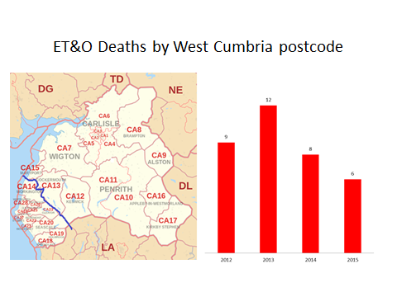

We also monitor other indicators which we know tell us a lot about patient wellbeing, such as the National Hip Fracture Database, which compares data from all UK hospitals. Hip fracture is not only one of the most common conditions where we have changed the place of patient care, but it is also considered nationally to be an ideal ‘marker’ condition with which to examine the quality and outcome of care offered to frail and older patients. In other words, it tells us about more than just hip fracture care and allows us to compare our performance not just year-on-year, but also against other UK hospitals.

The graph below shows a reduction in death after 30 days following admission with a hip fracture.

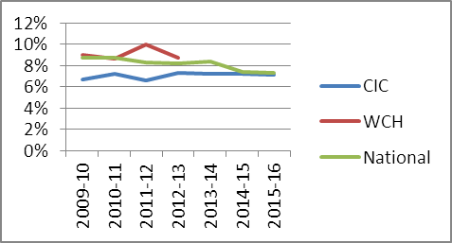

Our results have shown significant improvement, largely due to the changes we have made which have allowed us to concentrate team skills and resource on one site:

* A greater proportion of patients admitted to an orthopaedic ward within 4 hours (March 2015: NCUH 48%, national 46%). We now use a different measure of average time to admission: we perform better than average on this at 5.6 hours compared to national average of 9.2 hours.
* More patients with broken hips operated on within 36 hours.
* Patients are now looked after by a dedicated multidisciplinary hip fracture team, working across two sites made up of trauma co-ordinators trauma ward nurses, physiotherapists, occupational therapists, and social workers working with the medical team comprising 12 consultants who specifically take on hip fracture work within the wider team of trauma and orthopaedic doctors.
* Patients have access to a specialist orthogeriatric nurse and doctor. Trust peri-operative assessment by an orthogeriatrician has improved from 73.8% in 2014/15 to 92.4% at present.
* Good early mobilisation rates for patients after surgery.
* Reduced rates of pressure ulcers.
* Thanks to our dedicated discharge team, average length of stay is now significantly less than national average – a turnaround from the increase shown at WCH prior to centralisation. A lower length of stay is generally considered a good thing as it suggests more efficient care and rehabilitation. While some may argue it could mean patients are discharged too soon, this would show up in readmission numbers which, as shown in the table below, are low.

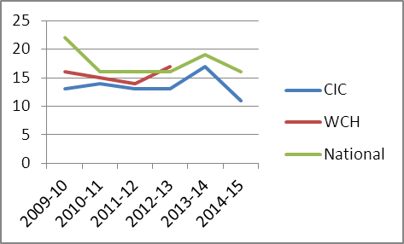

A higher tariff – known as a best practice tariff – is paid to trusts who perform well against nationally-recognised best practice quality indicators. The graph below shows the national improvement in the percentage of cases meeting the standards for best practice tariffs, with Cumberland Infirmary Carlisle now in line with national averages. This improvement started following from the point of centralising care onto the site.

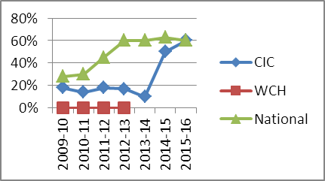

The following graph shows the reduction in pressure ulcer rates.

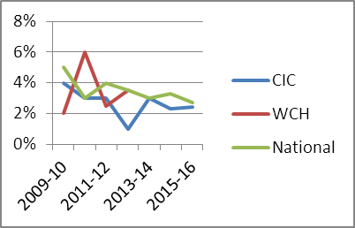

Services are now not only safer, they are also less vulnerable to sudden collapse due to workforce difficulties making them sustainable into the future.

We also see a similar picture in relation to death rates for emergency general surgery (EGS) in the table below.

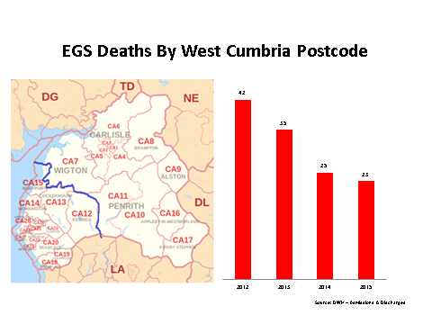

We continue to see this pattern even if we move the line south west, demonstrating that those living in furthest from Carlisle in west Cumbria have benefitted most from the changes, as shown in the table below.

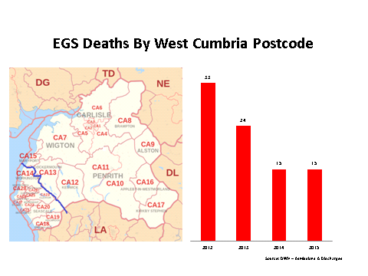

Although not the subject of this consultation, there are similar trends shown for emergency vascular, cardiology (myocardial ischaemia) and gastrointestinal bleeding.

By centralising and re-organising what were two failing “general” surgery on call rotas, we now have specialist gastrointestinal and vascular surgeons on site providing a 7-day service with improved outcomes across the board.

In emergency general surgery we use the National Emergency Laparotomy Audit as a good barometer of our performance and for the past two years the Trust has performance amongst the best in the country for:

* Promptness of senior review of emergency patients.
* Rapid treatment with antibiotics to prevent sepsis within two hours of admission.
* Time taken for emergencies patients to get to theatre.
* 100% of high risk cases have both a consultant anaesthetist and consultant surgeon present in theatre, compared to the national average of 72%.
* Early recovery and discharge home after emergency surgery.

Some facts and figures…

* Between April 2015 and March 2016 there were just under 500 patients admitted to the Trust with fractured hip; of these some 138 were transferred from West Cumberland hospital – an average of less than three each week.
* There are about 14 general surgical transfers from West Cumberland Hospital to Carlisle each week (as well as other more specialist surgical transfers such as ENT, vascular etc.), and 10 or 11 trauma/emergency orthopaedic weekly transfers.
* It is estimated that with our new emergency pathways four general surgery cases and three trauma cases each week (208 and 156 respectively per year) will now be able to be safely managed on the West Cumberland site.
* More than 500 annual elective and day case procedures have been transferred from Carlisle to Whitehaven since January 2015.
* Of the current 300,000 outpatient consultations each year in Carlisle, over 31,000 are for patients living in West Cumbria postcodes – in our proposals it is planned for many of these patients to receive local care in future.

Further reading

* [*Commissioning Guidelines for acute abdominal pain (Apr 2014)*](http://www.wnecumbria.nhs.uk/wp-content/uploads/2016/09/Commissioning-guidelines-for-acute-abdominal-pain-Apr-2014-Royal-College-of-Surgeons.pdf)
* [*Cumberland Infirmary performance – National hip fracture database*](http://www.wnecumbria.nhs.uk/wp-content/uploads/2016/09/Cumberland-Infirmary-performance-National-Hip-Fracture-Database.pdf)
* [*Emergency general surgery challenges and opportunities report (Apr 2016)*](http://www.wnecumbria.nhs.uk/wp-content/uploads/2016/09/Emergency-general-surgery-challenges-and-opportunities-report-Apr-2016-Nuffield-Trust.pdf)
* [*Fractures (non-complex) assessment and management guidance (Feb 2016)*](http://www.wnecumbria.nhs.uk/wp-content/uploads/2016/09/Fractures-non-complex-assessment-and-management-guidance-Feb-2016-NICE.pdf)
* [*Hip fracture management guidance (June 2011)*](http://www.wnecumbria.nhs.uk/wp-content/uploads/2016/09/Hip-fracture-managemment-guidance-Jun-2011-NICE.pdf)
* [*National Emergency Laparotomy Audit reports*](http://www.nela.org.uk/reports)
* [*National Hip Fracture Database Annual report 2015*](http://www.wnecumbria.nhs.uk/wp-content/uploads/2016/09/National-Hip-Fracture-Database-annual-report-2015.pdf)
* *[The future of emergency general surgery – Assoc. of surgeons of GB and Ireland (March 2015)](http://www.wnecumbria.nhs.uk/wp-content/uploads/2016/09/The-future-of-emergency-general-surgery-Mar-2015-Association-of-Surgeons-of-Great-Britain-and-Ireland.pdf)*

